**Smart Wallet Project Phase I**

Javier Ortiz Jan Culpeper

Miguel Vazquez Edwin Borrero

Alberto Perez Gabriel Rosa

**Project Summary**

A design and development project for users wishing to handle their receipts more efficiently. Project will consist of a GUI that will allow users to create their profiles, log their receipts, organize them, and request them, as well as a database to store this information. The team mentioned above will begin the design, implementation, and testing of the project which will take approximately one semester to complete.

**Changes from the previous phase**

During this phase there have been some small changes with the scope and domain of project. Mainly the removal of the payment management. The app will now focus on storing and managing a user’s receipts for storage and budgeting. The application will also now be a web application instead of a mobile application. A web platform will allow the system to work on any device with a web browser.

**UI prototype**

**Project Backlogs**

During the work for this phase the project backlogs have also been developed. These backlogs list most of the tasks to be done in order to complete development of the initial application. They will span from the beginning of development until the end of the initial version of the application.

**Front-end Backlog**

For this backlog, user stories were listed. These describe the different tasks that should be done to satisfy the user’s needs in the application. To see the user stories, refer to the file named FE Backlog.

**Back-end Backlog**

This backlog contains user stories related to each different task to be accomplished related to the backlog design and implementation. It also contains the acceptance criteria for each item. For this information refer to the file called BE backlog

**Entity Relation Diagram**

/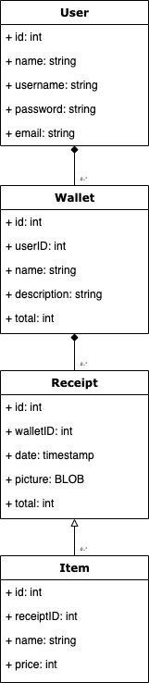

**Use Case Description**

There will be various scenarios of usage with our app, the first one will always be the user login into their account or creating one if necessary. When this happens, the system will prompt the user for their credentials which will then be validated with the system’s database and, if correct, the user will be taken to the main page of the webapp; otherwise an error message will be displayed and the user will be prompted for the credentials once again. After reaching the main page, the user is shown a collection of their receipts, from which they can search them using various criteria like filtering by date, by location, or by amount of transaction.